## Logo Description automatically generated未标题-1

**Sustainable Outreach And Universal**

**Leadership (SOUL) Limited**

**Software Requirement Specification (SRS)**

Of

**Application Master module**

For Implementation of

**Campus Management Software**

at

**World Skill Center (WSC)**

**Table of Content**

A. Abstract 3

B. Introduction 3

C. Definition, Acronyms and Abbreviations 3

D. Overview of the Document 4

1. Application Master 5

1.1 Country 5

1.2 State 6

1.3 Districts 7

1.4 Block 7

1.5 Religion 8

# Abstract

Software Requirements Gathering is one of the first phases of system development. This phase results in the Software Requirements Specification (SRS) document, which must contain a complete, concise, high-quality description of the system being considered.

# Introduction

The World Skill Center (WSC) is a premier advanced skill training institute established by the Government of Odisha, Skill Development and Technical Education Department, through the Odisha Skill Development Authority (OSDA). The WSC will impart advanced skill training in eight trades from engineering and service sectors. WSC caters primarily to induct the best talent from ITIs and Polytechnics and train them to become globally employable in emerging areas such as "Industry 4.0". WSC is housed in a state-of-the-art, 18-storey, air-conditioned building with nearly half a million square feet of space in the heart of capital city of Bhubaneswar.

With the Implementation of campus management software for WSC the goal is to streamline the operations and functions of the campus by integrating various processes, such as admissions, course registration, academic progress tracking, and financial management, HRMS, Procurement and Inventory management, etc into a unified system. The implementation also aims at providing a user-friendly interface for all stakeholders, making it easier for them to access the necessary information and complete their tasks with ease. The modules to be covered during the implementation of the software includes:

|  |  |
| --- | --- |
| Students Management Modules | Infrastructure Management |
| Academic System | Finance and Accounting System |
| Procurement & Inventory Management | Training and Placement |
| Human Resources Management System | Application Integration |

# Definition, Acronyms and Abbreviations

The following table explains the terms and abbreviations used in the document:

|  |  |
| --- | --- |
| **Abbreviation** | **Description** |
| SRS | Software Requirements Specification |
| SLCM | Student Life Cycle Management |
| R | Rename - When a field is Renamed |
| N | New - When a New field is Added |
| D | Delete - When an Existing field is Deleted |
| NA | Not Applicable |

# Overview of the Document

This requirement document provides a detailed overview of the functional requirements of a project. It serves as a communication tool between stakeholders, including developers, project managers, and end-users. The purpose of this requirement document is to define and document the project's objectives, scope, and expectations, and to ensure that all stakeholders have a clear understanding of what the project entails.

This document covers all the functional requirements of the **Admission module** of ERP Product. This module helps in organizing the entire admission set-up, such as Student Database, Counselling, Student Application Form, Fee Structure, Trainers Information, Course Enrollment, etc.

## Application Master

## Country

**General Description**

The following table describes overall information about this screen:

|  |  |
| --- | --- |
| **Description** | Country is Master Screen, we can create different country such as India, Afghanistan, etc. This will be fetched when creating new addresses. |
| **Navigation** |  |
| **Pre-requisites** |  |

**Screenshot**

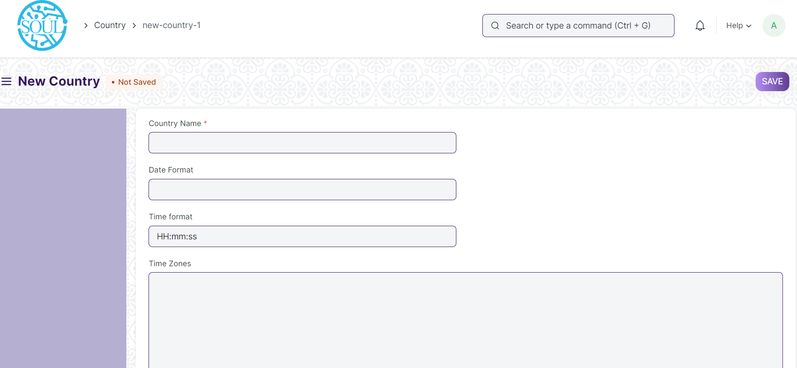

Figure 26 : Country

**Field List**

The following table describes the UI fields present in this screen:

|  |  |  |  |  |
| --- | --- | --- | --- | --- |
| **ID** | **Label** | **Type** | **Mandatory** | **Validation / Action** |
| 1 | Country Name | Text | Yes |  |
| 2 | Date Format | Text |  |  |
| 3 | Time Format | Text |  |  |
| 4 | Time Zones | Long Text |  |  |
| 5 | Code | Text |  |  |
| 6 | Country Phone Code | Text |  |  |

**Users: Roles & Permission**

The following table describes the users and their roles and permissions for the screens :

|  |  |  |  |  |  |  |  |  |  |
| --- | --- | --- | --- | --- | --- | --- | --- | --- | --- |
| **ID** | **Role** | **Select** | **Read** | **Write** | **Create** | **Delete** | **Submit** | **Cancel** | **Amend** |
| 1 | Admin | Yes | Yes | Yes | Yes | Yes | NA | NA | NA |

## State

**General Description**

The following table describes overall information about this screen:

|  |  |
| --- | --- |
| **Description** | State is Master Screen, you can create different states such as Odisha, West Bengal, etc |
| **Navigation** |  |
| **Pre-requisites** | Country |

**Screenshot**

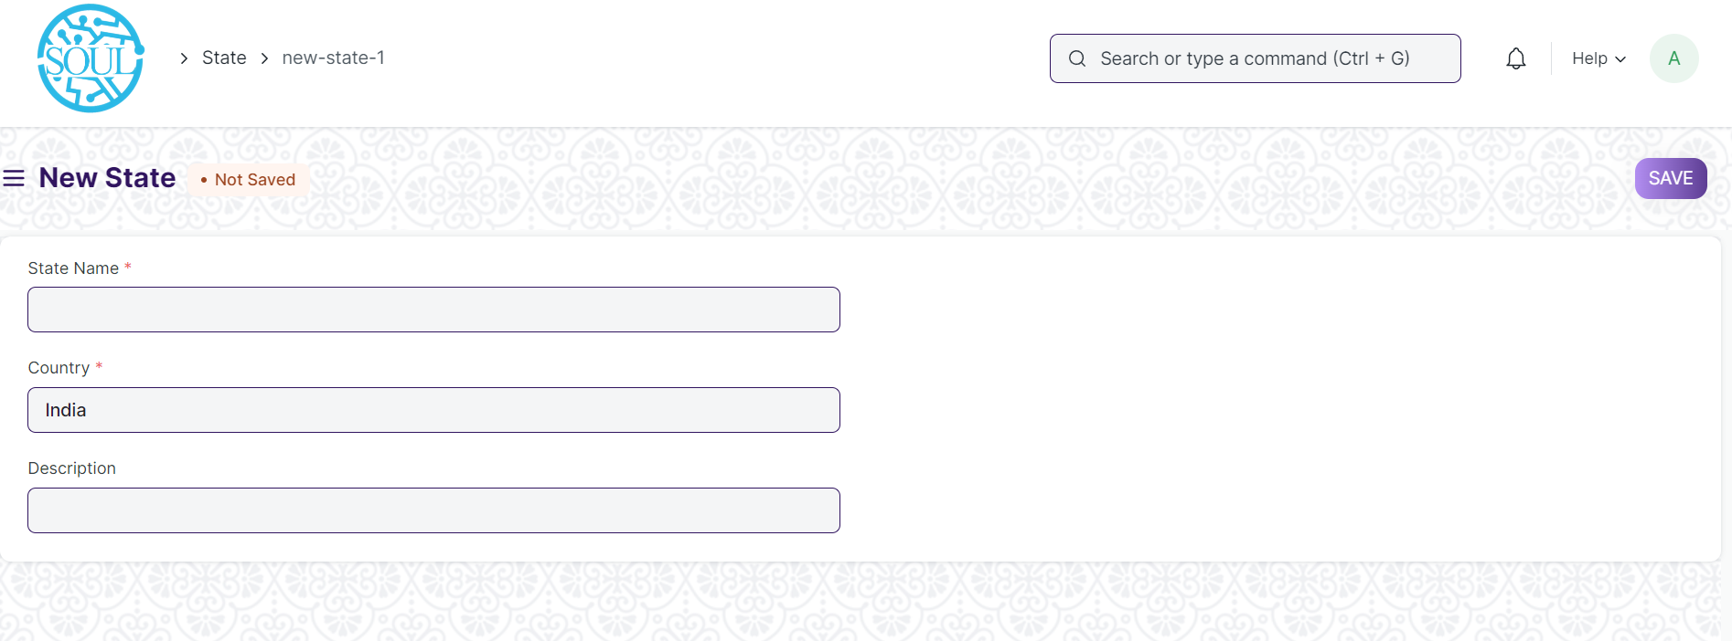

Figure 27 : State

**Field List**

The following table describes the UI fields present in this screen :

|  |  |  |  |  |
| --- | --- | --- | --- | --- |
| **ID** | **Label** | **Type** | **Mandatory** | **Validation / Action** |
| 1 | State Name | Text | Yes |  |
| 2 | Country | Link Field |  | Links to Country Screen |
| 3 | Description | Long Text |  |  |

**Users: Roles & Permission**

The following table describes the users and their roles and permissions for the screens :

|  |  |  |  |  |  |  |  |  |  |
| --- | --- | --- | --- | --- | --- | --- | --- | --- | --- |
| **ID** | **Role** | **Select** | **Read** | **Write** | **Create** | **Delete** | **Submit** | **Cancel** | **Amend** |
| 1 | Admin | Yes | Yes | Yes | Yes | Yes | NA | NA | NA |
| 2 | Student Applicant | Yes | Yes | No | No | No | No | No | No |
| 3 | Student | Yes | Yes | No | No | No | No | No | No |

## Districts

**General Description**

The following table describe overall information about this screen:

|  |  |
| --- | --- |
| **Description** | District is Master Screen, you can create different district name such as Khordha, Kandhamal, etc in the state Odisha |
| **Navigation** |  |
| **Pre-requisites** | State |

**Screenshot**

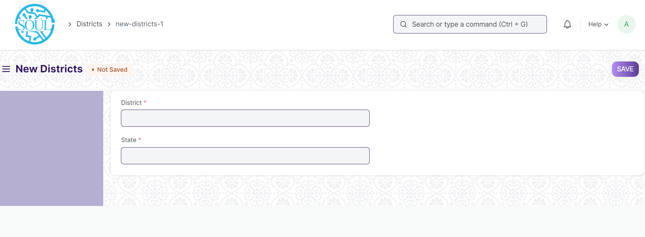

Figure 28 : District

**Field List**

The following table describes the UI fields present in this screen :

|  |  |  |  |  |
| --- | --- | --- | --- | --- |
| **ID** | **Label** | **Type** | **Mandatory** | **Validation / Action** |
| 1 | District | Text | Yes |  |
| 2 | State | Links to State Screen |  |  |

**Users: Roles & Permission**

The following table describes the users and their roles and permissions for the screens :

|  |  |  |  |  |  |  |  |  |  |
| --- | --- | --- | --- | --- | --- | --- | --- | --- | --- |
| **ID** | **Role** | **Select** | **Read** | **Write** | **Create** | **Delete** | **Submit** | **Cancel** | **Amend** |
| 1 | Admin | Yes | Yes | Yes | Yes | Yes | NA | NA | NA |
| 2 | Student Applicant | Yes | Yes | No | No | No | No | No | No |
| 3 | Student | Yes | Yes | No | No | No | No | No | No |

## Block

**General Description**

The following table describe overall information about this screen:

|  |  |
| --- | --- |
| **Description** | Block is Master Screen, you can create different blocks name such as Baranga, Niali, etc in the Cuttack district of Odisha |
| **Navigation** |  |
| **Pre-requisites** | District |

**Screenshot**

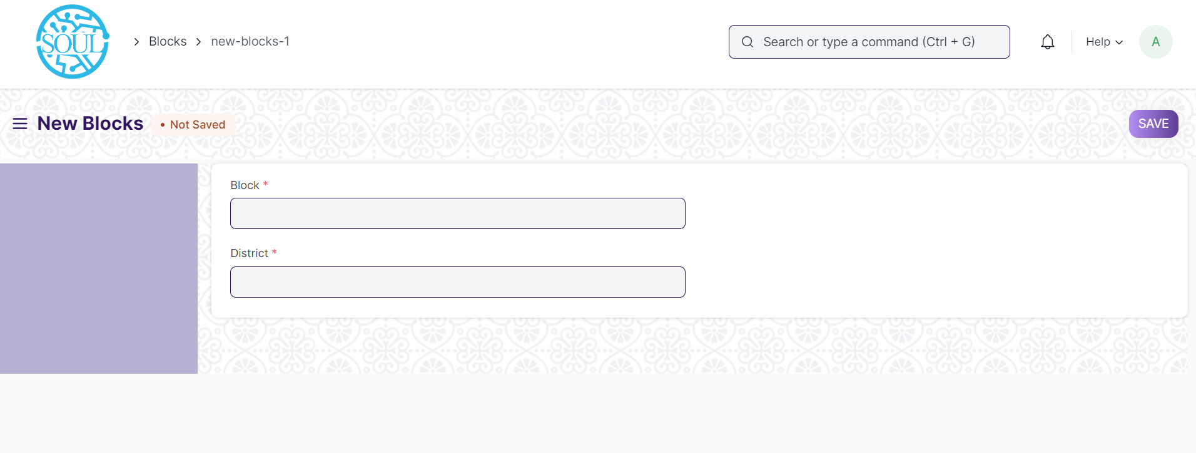

Figure 29 : Block

**Field List**

The following table describes the UI fields present in this screen :

|  |  |  |  |  |
| --- | --- | --- | --- | --- |
| **ID** | **Label** | **Type** | **Mandatory** | **Validation / Action** |
| 1 | Block Name | Text | Yes |  |
| 2 | District | Links to State Screen |  |  |

**Users: Roles & Permission**

The following table describes the users and their roles and permissions for the screens :

|  |  |  |  |  |  |  |  |  |  |
| --- | --- | --- | --- | --- | --- | --- | --- | --- | --- |
| **ID** | **Role** | **Select** | **Read** | **Write** | **Create** | **Delete** | **Submit** | **Cancel** | **Amend** |
| 1 | Admin | Yes | Yes | Yes | Yes | Yes | NA | NA | NA |
| 2 | Student Applicant | Yes | Yes | No | No | No | No | No | No |
| 3 | Student | Yes | Yes | No | No | No | No | No | No |

## Religion

**General Description**

The following table describes overall information about this screen:

|  |  |
| --- | --- |
| **Description** | Religion is a Master Screen, where we can create different religion names such Muslim, Hinduism, Christianity, etc. |
| **Navigation** |  |
| **Pre-requisites** |  |

**Screenshot**

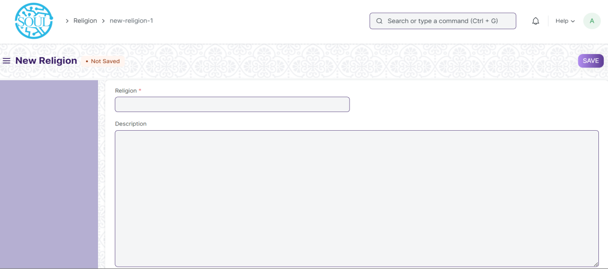

Figure 33 : Religion

**Field List**

The following table describes the UI fields present in this screen:

|  |  |  |  |  |
| --- | --- | --- | --- | --- |
| **ID** | **Label** | **Type** | **Mandatory** | **Validation / Action** |
| 1 | Religion | Text | Yes |  |
| 2 | Description | Long Text |  |  |

**Users: Roles & Permission**

The following table describes the users and their roles and permissions for the screens :

|  |  |  |  |  |  |  |  |  |  |
| --- | --- | --- | --- | --- | --- | --- | --- | --- | --- |
| **ID** | **Role** | **Select** | **Read** | **Write** | **Create** | **Delete** | **Submit** | **Cancel** | **Amend** |
| 1 | Admin | Yes | Yes | Yes | Yes | Yes | NA | NA | NA |
| 2 | Student | Yes | Yes | No | No | No | No | No | No |
| 3 | Student Applicant | Yes | Yes | No | No | No | No | No | No |